1-d

F-Score for test dataset: 0.9343065693430657

1-f

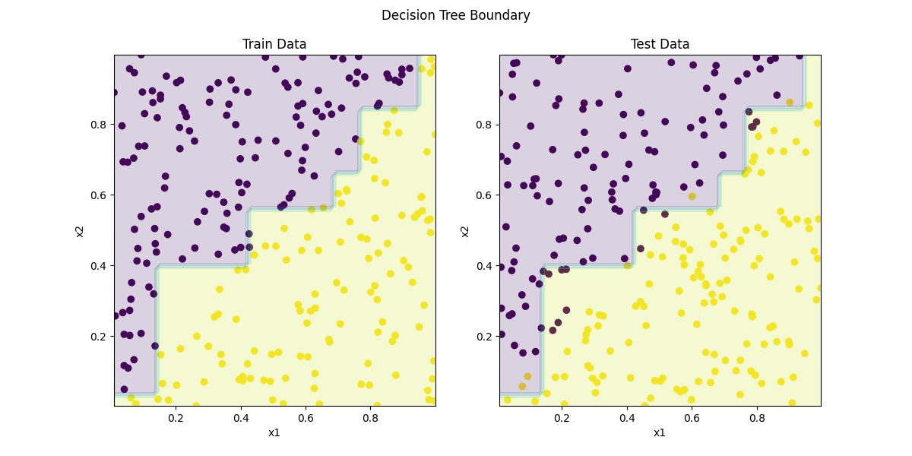

2-e

Cross-Entropy Loss: 0.09429917305851708

2-f

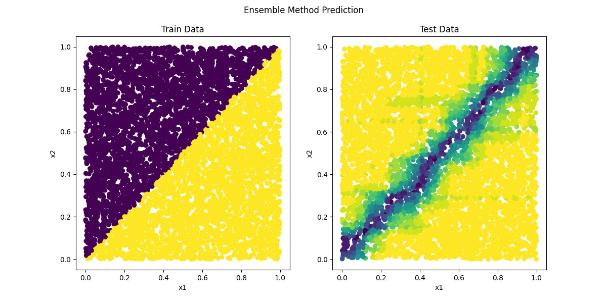

3-e

Gini Impurity for xdiv=-5 = 0.34426229508196726

Gini Impurity for xdiv=-2 = 0.20703125

Gini Impurity for xdiv=0 = 0.23702313946216383

Gini Impurity for xdiv=1 = 0.14893617021276603

Gini Impurity for xdiv=10 = 0.4736842105263158